Bioinformatic approach to epigenetics Project Work
Idea #1
Comparison of the bindings of different CREB family members and cofactors (in K562 cell line, data available from ENCODE)
Background:
“Regulation of transcription by PKA is mainly achieved by direct phosphorylation of the transcription factors cAMP-response element-binding protein (CREB), cAMP-responsive modulator (CREM), and ATF1. Phosphorylation is a crucial event because it allows these proteins to interact with the transcriptional coactivators CREB-binding protein (CBP) and p300 when bound to cAMP-response elements (CREs) in target genes (Mayr and Montminy 2001). The CREM gene also encodes the powerful repressor ICER, which negatively feeds back on cAMP-induced transcription (Sassone-Corsi 1995). Note, however, that the picture is more complex, because CREB, CREM, and ATF1 can all be phosphorylated by many different kinases, and PKA can also influence the activity of other transcription factors, including some nuclear receptors.” (https://www.ncbi.nlm.nih.gov/pmc/articles/PMC3504441/)
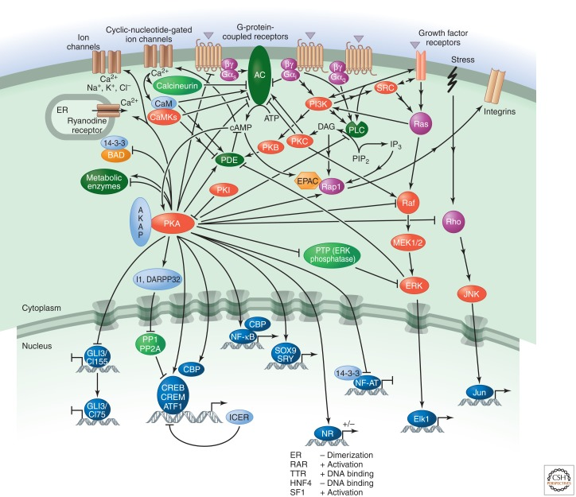
Transcriptional regulation by the phosphorylation-dependent factor CREB https://www.nature.com/articles/35085068
Background: Cyclic adenosine monophosphate (cAMP) is a key intra-cellular signaling pathway in a variety of biological contexts, and its main impacts in terms of transcription are through the cAMP responsive elements, which are bound by TFs that are members of the CREB family. CREB is already bound to DNA, and when cAMP goes up it gets phosphorylated, which then attracts cofactors, in particular the CREB-binding protein CREBBP. There are different members of that family, and while we know a lot about CREB1, we don't know much about the others.
If you look at the encode website, you'll see that in that cell type (K562) there is data for: What about CREB5 (https://www.encodeproject.org/experiments/ENCSR935PEA/)
CREB1 (https://www.encodeproject.org/experiments/ENCSR000BSO/)
CREB3 (https://www.encodeproject.org/experiments/ENCSR093FKD/)
CREB3L1 (https://www.encodeproject.org/experiments/ENCSR109YGM/)
The first question would be: do these factors bind at the same places, or at different places?
Is it correct to work with TF ChiP-seq data? (see links above)
Most likely, the answer will be that they share some binding sites, but not all of them, and we can then investigate whether there's a logic to those different sets (e.g. are the sets bound only by CREB1 different in some ways to those bound also by the others?).
To investigate this, we'll look at H3K27ac and important co-factors of CREB1:
What is H3K27ac?
“histone H3 lysine 27 acetylation (H3K27ac) is considered a hallmark of trithorax group (trxG) mediated gene activation that antagonizes repression by Polycomb group (PcG) proteins (Tie et al., 2009).” (https://www.ncbi.nlm.nih.gov/pmc/articles/PMC8509297/)
CREBBP (https://www.encodeproject.org/genes/1387/)
JUN (https://www.encodeproject.org/genes/3725/)
EP300 (https://www.encodeproject.org/genes/2033/)
HDAC2 (https://www.encodeproject.org/genes/3066/)
You've already got all the data (Do we use the data in these links?) processed from ENCODE, so in order to do this you'd only need the disk space to handle the processed files (probably 3GB or so).
So do we look at how the binding proteins above interact with H3K27ac and if these correlate with CREB binding?
Idea #2
Comparison of the bindings of GR and MR receptors in the hippocampus upon stress. Using data from https://www.nature.com/articles/s41467-021-24967-z which was only superficially analysed in the publication. (Chiefly ChIP-seq, requires reprocessing - hence some computing power, but otherwise not too complicated)
- Background Infos to GR and MR: https://www.intechopen.com/chapters/67891
- “The mineralocorticoid receptor (MR) and glucocorticoid receptor (GR) are highly homologous members of the Steroid Receptor Family of ligand activated transcription factors that initiate or suppress the transcription of effector proteins, as well as initiate rapid non-genomic, or extra-nuclear, events through several cell signaling pathways. As transcription factors, MR and GR compete for the same ligands, form homodimers and heterodimers with each other, bind many of the same hormone response elements on the DNA, and share many co-regulatory proteins required for the efficient initiation of gene transcription.” (https://www.ncbi.nlm.nih.gov/pmc/articles/PMC4521600/)
- DATA: https://www.ncbi.nlm.nih.gov/geo/query/acc.cgi?acc=GSE126706
- Compare the rats killed under normal conditions AM to the rats killed under PM or Stress, specifically look at GR and MR (can already be found in the data seperated)
- So do we look at how accessible the GR and MR genes are at rest or under stress? And according to that we can determine whether they are expressed or not?

